Moonbounce Folding Guide
Note for setting up:
There will be two tubes for two 1 hp blowers but I provide one 2 hp blower. When setting up use the strap on one of the tubes to close the tube shut so that air doesn’t escape out.

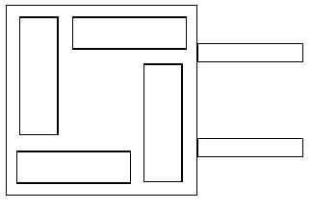

Folding Guide:

1. Turn the blower off – switch down. Then loosen both straps on the tubes. Let the inflatable deflate. Place the columns like shown in the image to the left. Put them all going either clockwise or counterclockwise.

corners meet at central arrow
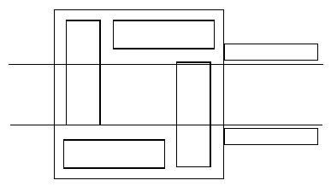
2. Fold along these lines into the center so that the indicated corners meet in the center.

Should look like this.
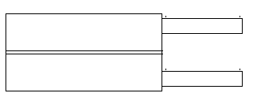

Same for this side

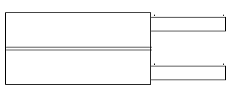
3. Now fold it in half at the arrow shown….
4. Now roll it starting from the opposite side of the tubes (see arrow on bottom image). The tighter you roll the more compact it will be. Once you get to the tubes fold and tuck them inside the roll.

5. Once it is rolled please wrap it with the blue tarp that it was wrapped with before to avoid any potential damage while transporting it in the car.

…The result of step 3 should look like this:
6. Finally use the two black straps and strap them around it so that it does not unroll and it will be easier to load/unload it.

Thank You!

